DICOM Print Sender

This tool is using to simulate to print DICOM files to our PS system. Then PS will recognize the DICOM with OCR process and archive the DICOM files. We can use it to simulate the print operations in hospitals when do the performance testing works.

The tool will start multiple threads and print the define DICOM files with dcmtk open source tool. We define multiple work rules to fit the different requirements.

The main work flow as follow:

1. The tools will init with parameters with configuration file.
2. Get the work model with the settings.
3. Try to create patient with integration service which define as the “local RIS”.
4. Add the water mark to DICOM files with small tool.
5. Print the DICOM file to destination PS system.

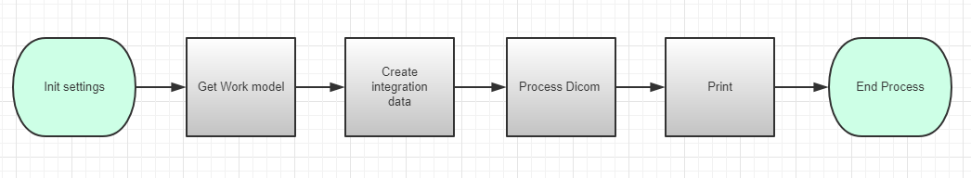

**Init Setting:**

Tool will reads the configuration file and get the parameters. It will create related work folder and change the default value to ensure tool can works well.

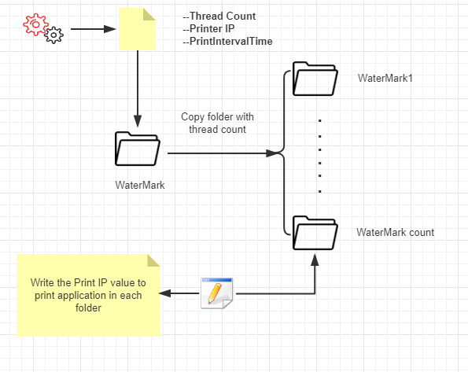

The application will do the follow operations during the init function:

1. Read the “App.config” in the applications.
2. Get the required parameters: ThreadCount, PrinterIP, PrintIntervalTime
3. Copy and create new watermark folder with thread count. The name style is as WaterMark1, WaterMark2……WaterMark[thread count].
4. Go to each WaterMark folder and change the print IP to the target PS. Change the **hostname** value of configuration file ..\SCU\dcmpstat.cfg.scu to the one which defined in your configuration file.

**Get work model:**

As design, the application has 3 work models and 1 loop rule. The 3 works modes are “Manual”, “Count”, “Time”. If user chooses any of them, the application will execute with different rules. Use can change the configurations in the “App.config” file in the application.

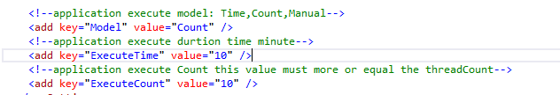

* Manual

In this model, the application will keep running until user input flag key to stop working.

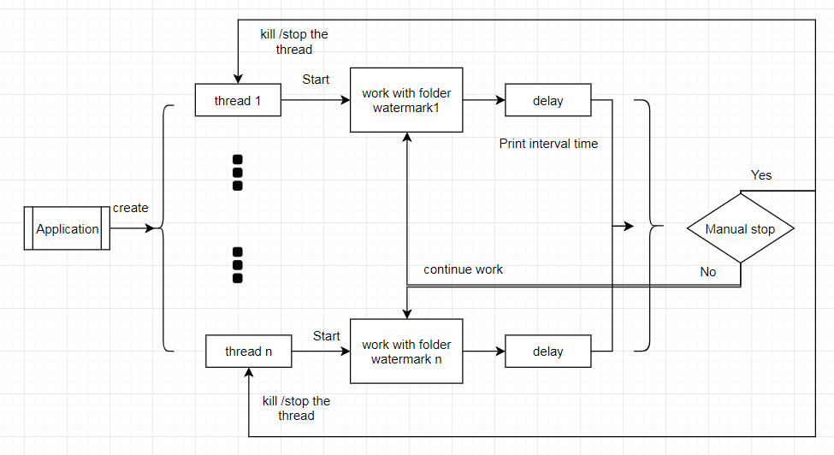

1. Application will start the multiple threads with the settings.
2. Each thread will work with it`s watermark folder.
3. Each thread will delay for several time when it single tasks finished. The delay time is configuration with the settings.
4. If user does not input stop flag for application, each threads will continue works.
5. If user does input stop flag for application, each threads will stopped when it finish it current task.

**Note:** User can input the flag in CMD windows which created by application.

* Count

In this model, the application will keep running until the dicom send counts of all threads is equal the setting one (executecount).

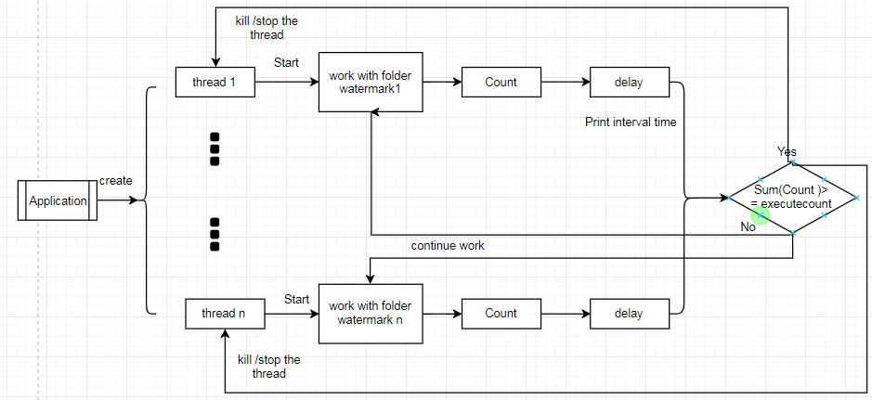

1. Application will start the multiple threads with the settings.
2. Each thread will work with it`s watermark folder.
3. Each thread will delay for several time when it single tasks finished. The delay time is configuration with the settings.
4. If the thread finished the main works flow, the system will count with a global variable.
5. If the global count is equal the define one, the application will stop the threads one by one until thread finish current task.

* Times

In this model, the application will keep running until the execute time is arrived the designed one. (Execute Time).

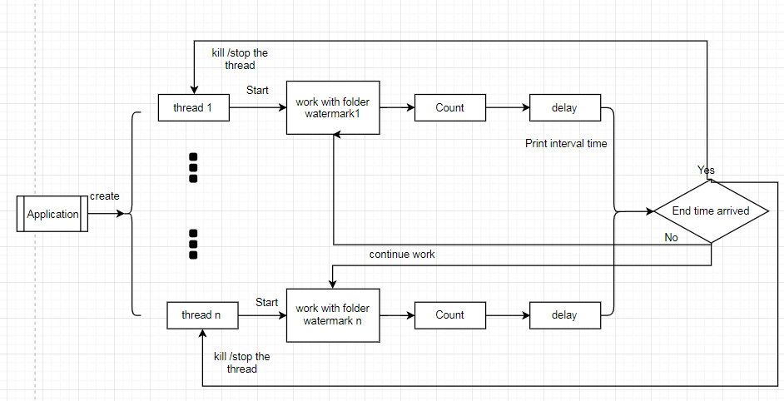

1. Application will start the multiple threads with the settings.
2. Each thread will work with it` s watermark folder.
3. Each thread will delay for several time when it single tasks finished. The delay time is configuration with the settings.
4. When the application start, it will record the current time and plus the execute time (minute) as the application end time.
5. If the global application end time arrived, the application will stop the threads one by one until thread finish current task.

* Loop model

We can see this a loop mode configuration in the app.config file. There are three options about it:

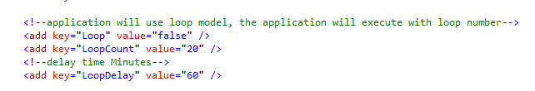

If loop option set as true, the loop module will works. “LoopCount” is means the loop count for application. The “LoopDelay” options is mean when the application finish one loop and wait for some times.

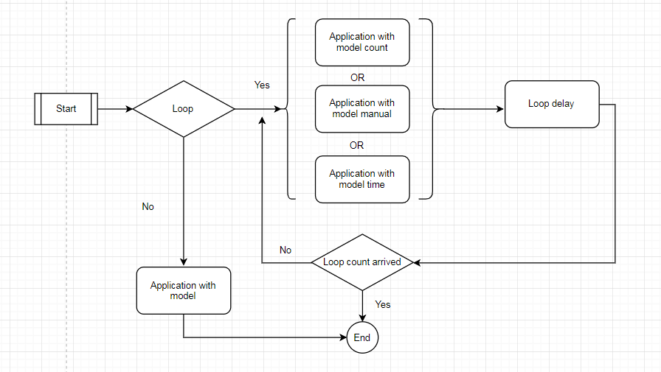

1. Application will check the loop option enable or not.
2. If the options enable, it will be start loop.
3. Application will start the multiple threads with the settings and work with define model: manual, time or count.
4. After define work model is finished, the application will delay some minutes with the defined loop delay settings.
5. Application will start next loop until all loops finished.

**Create integration data:**

The Print service will send the request to 3rd system with integration API to verify the patient exists or not.

QA team offer an integration install on file server. It can simulates the RIS with local database. You can get it on 10.184.129.235\puma\integration\autoRIS. Download the package and copy to local disk to install it.

If the integration has installed and configure successfully, the application can works well with it. The Application will send the request to the integration and create a patient with PID and ACCN. The rule is get the current date time with style as ‘yyMMddHHmmssf’, then add ‘P’ or ‘A’ as first character, add the thread count id at the last postion.

PID: P + ‘yyMMddHHmmssf’ + thread loop count id.

Accn: A + ‘yyMMddHHmmssf’ + thread loop count id.

**Note: make sure the OCR rule has configured with correct rule in OCR configuration in PS. It will works with the integration service.**

**Process DICOM file:**

The application will start and maintain several threads to simulate the workstation print operations. Each threads will process their DCOM files and print to PS. Develop team offer a small tool to add watermark on DICOM file with define parameters.

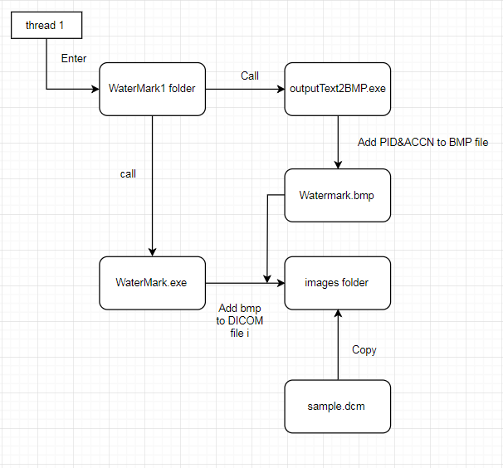

1. The thread will execute CMD to add watermark to BMP file with PID and ACCN.
2. Copy the DICOM file which name as “sample.dcm” to the folder “images”.
3. Execute the CMD to call the WaterMark.exe to add the water mark to the DICOM file.

Print DICOM

After the application add the water marker to DICCOM files, it will print them to PS. The operation is use the dcmpsprt.exe and dcmprscu.exe to simulate the print DICOM.

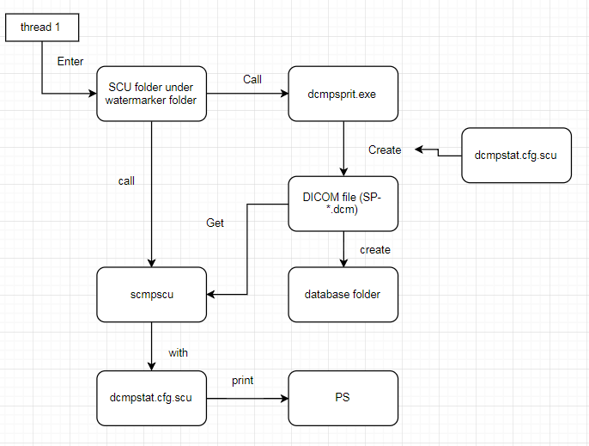

1. The thread will execute CMD to dcmpspit.exe with parameters to create DICOM file. The application will create the DICOM to database folder.
2. Execute the CMD to call the dcmprsct.exe to print the DICOM file with configuration file “dcmstat.cfg.scu”.

<End of document>